

**Green University of Bangladesh**

**Department of Computer Science and Engineering(CSE)**

**Faculty of Sciences and Engineering**

**Semester: (Summer, Year:2021), B.Sc. in CSE (Day**

**Project Report on**

**3D duplex house**

Course Title: Engineering Drawing

Course Code: CSE-208              Section:193DB

**Student Details**

|  |  |  |
| --- | --- | --- |
| Name | | ID |
| 1. | Nazifa Alam Nowrin | 193002103 |
| 2. | Nur A Neouse | 193002093 |
| 3. | Jakirul Islam | 193002101 |

Course Teacher’s Name : Mr. Abdullah Al Arif

|  |
| --- |
| Status  Marks: …………………………………                              Signature:.....................  Comments:..............................................                              Date:.............................. |

Chapter 1 Introduction

1.1 Introduction 3

1.2 Statement of the Problem 3

1.3 Scope of the Work 3

1.4 Design Goals 3

1.5 Outline 4

Chapter 2 design method and procedures

2.1 Introduction 5

2.1 Section 6

2.2 Section 6

2.3 Summary 6

Chapter 3 Performance Evaluation

3.1 Introduction 7

3.2 Simulation Environment/ Simulation Procedure 8

3.3 Basic Data 9-12

3.4 Results and Discussions 13

3.5 Summary 13

Chapter 4 Conclusion

4.1 Introduction 14

4.2 Discussion/ Concluding Remarks 14

4.3 Practical Implications 14

4.4 Scope of Future Work 14

**CHAPTER1**

**INTRODUCTION**

* 1. **Introduction**

Computer Aided Designing is one of the most important enhancements for the new generation engineers. Labor system in the modern design offices, their cooperation with the architects, investors and even contractors requires rapid reacting on the new changes and ideas within the realized investments. It obviously leads to the necessity of quick modifications of the implemented solutions or quick recalculation of the designed object parameters. In such a dynamic world, the traditional methods of designing become ineffective. One of the most important tools for Computer Aided Designing – AutoCAD. It is a graphical program used by almost each designing office. Whole description is based on AutoCAD 2022 edition and the special attention is put on modeling of three-dimensional objects. In this project we will be discussing about the 3D duplex house modelling. A 3D duplex house is a type of diagram that presents 3D floor planning as well as 2D floor planning of both the first and the second floor. these floor plans include walls, room layout, fixed installations like windows, doors, stairs as well as furniture

1.2 **statement of the problem**

the name of our project id 3D duplex house modelling. this project will give a person a whole idea of a duplex house plan. our project shows the details of two individual floor plans, wall types, opening directions, orientation of doors and windows which includes the measurement of surface area and each sections.

**1.3 scope of the work**

The main aim of our project is to design and analyze a 3D duplex house modelling by using the software AUTOCAD 2022. This project also enhances our ability to use different kind of tools in AUTOCAD software.

**1.4 Design goals**

the 3D duplex house model gives us clear overview of the design of the entire house, property layout that includes interior layout also. this project is great for home designs, interior designs, home renovations, property layouts, office layouts, commercial spaces, flooring layouts etc.

**1.5 outline**

chapter 2 : The design methods and procedure

chapter 3: Performance evaluation

chapter 4 : Conclusion

**CHAPTER 2**

**DESIGN METHOD AND PROCEDURES**

**2.1 Introduction**

A duplex house plan needs to assist design processes when making decisions about space planning, furniture layouts and circulation requirements. This also need to support discussions with architect to enable accuracy and communicate with confident designs and visions for a space. In this section we will discuss about the tools that we have used for the 3D duplex house modeling.

**Tools :**

Software :

Autocad 2022

**List of of equipments :**

1. Computer

2. Autocad 2022

**List of tools :**

1. Move

2. Copy

3. Filet

4. Dimension

5. Trim

6. Array

**Shapes used :**

1. Rectangle

2. Circle

3. Poly Line

4. Line

5. Rectangular array

6. Box

7. Spiral

**2.2 Section 1**

There are 2 floor plans in our duplex house design. The first floor has a living room, kitchen, laundry, toilet, bedroom, bath, study room, garrage.

1. Living room : 245’*235.5’
2. kitchen : 91.5’*78’
3. Laundry: 87’*88.5’
4. Toilet : 36’*60’
5. Bedroom :88.5’*70.5’
6. Bath : 127.5’*72’
7. Study room : 111’*162’
8. Garage : 175’*180’

**2.2 Section 2**

The second floor have 3 bedrooms, 2 toilets, kitchen, laundry, guest room.

**3 bedrooms :**

1. bedroom 1: 243’*156’
2. bedroom 2: 127.5’*112’
3. bedroom 3: 144’*127’5’

**2 toilets :**

1. toilet 1: 60’*75.5’
2. toilet 2: 63’*75.5’
3. kitchen :111’*123’
4. Laundry: 75’*72’
5. Guest room:160’*70.5’

**2.3 Summary**

This project helps us to learn how to design and plan a duplex house including the first floor and second floor. We have given accurate dimension for every room also we have learned how to turn 2d objects into 3d ones. Furthermore, we have learned how to make different kinds of furniture for rooms

**CHAPTER 3**

**PERFORMANCE EVALUATION**

**3.1 Introduction**

In this section, we will show the implementation of the 3d duplex house with different views.

**3.2 Simulation procedures :**

Front view of 1st floor :

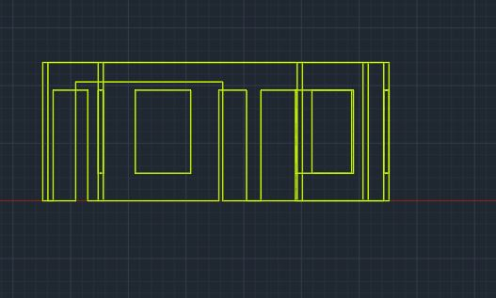

Back View of 1st floor:

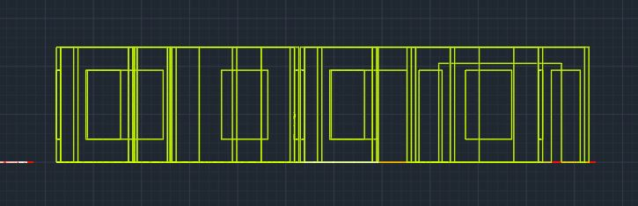

Top View of 1st floor:

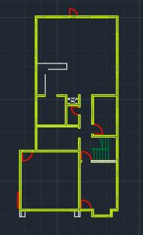

Se Isometric View of 1st floor:

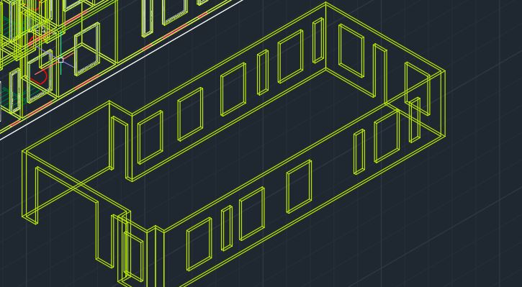

Front view of 1st floor :

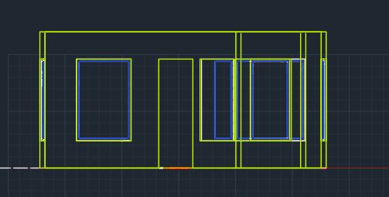

Left View of 2nd floor:

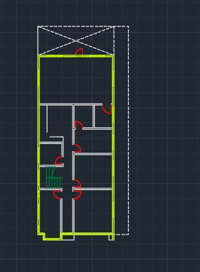

Proper Top View of 2nd floor:

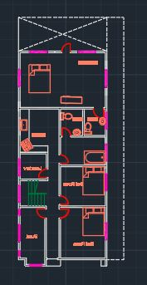

Proper Left View of 2nd floor:

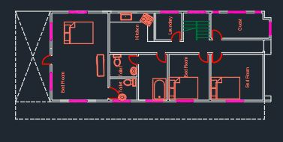

SW Isometric View of 3d duplex house:

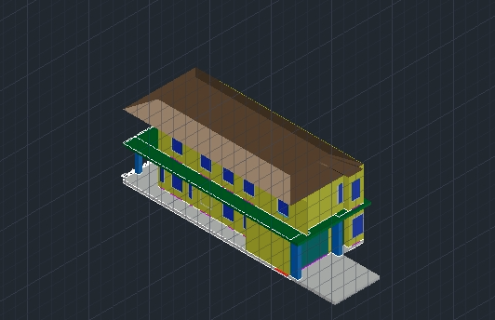

EW Isometric View of 3d duplex house

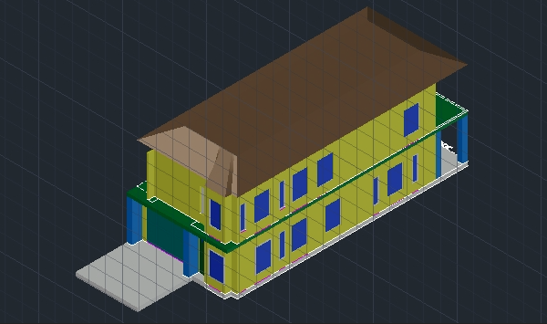

3D X-RAY view of duplex house :

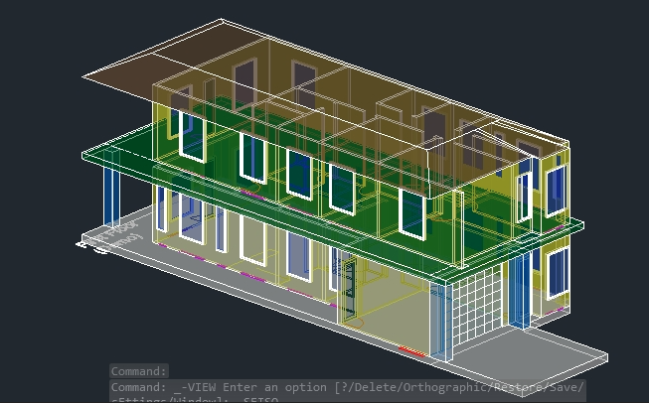

2D wireframe view of duplex house:

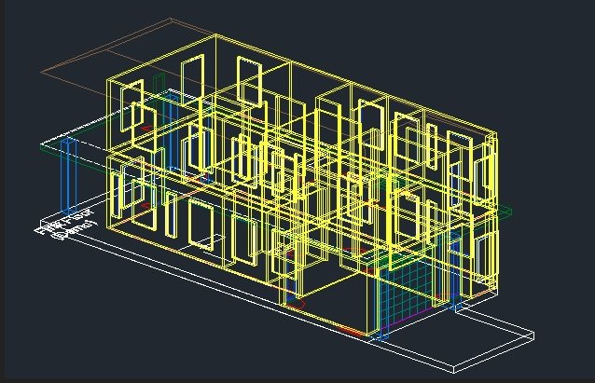

**3.3 Result and discussions :**

**Result :**

We have successfully created the 3d duplex house and has shown various views of the project including top, back, front, se isometric view, N-W isometric view, x ray and 2d wireframe view

**Discussion :**

* Each measurements is taken very carefully.

* Steps has been taken very carefully to draw the door of a room so that it fits perfectly.

* Whole object is selected very carefully to copy an object before moving.

* Each angle has been taken carefully to rotate an object.

* To use the filet tool, radius has been written first and then two corners has been selected carefully.

**3.4 Summary :**

From this experiment, I have learnt how to plan and design a duplex house. I have also learnt how to use different tools in Autocad to design a 3D object. Also I have learnt how a blueprint of a house plan is created before the building is in the physical form.

**CHAPTER 4**

**CONCLUSION**

**4.1 Introduction**

3d duplex house shows the basic outline of a property including walls, doorways, windows and entrances. This project shows the layout of rooms very clearly and is a flat drawing showing the property from above without any depth. In this project 3d duplex house design has been sketched by Autocad 2022.

**4.2 Discussion / concluding remarks**

1. Before modelling the house, we have to plan total area of the house.

2. Then we have to plan the areas for the bedroom, kitchen and other sections.

3. We have designed the area for the staircase in such way that we can access both floors.

4. We have to ensure that the area and the height of both floors are the same.

5. In order to make the model more realistic, we have added architectural features to it.

6. We have given detailed information about each room area and dimensions.

**4.3 practical implications :**

* creating blueprints for duplex floors.

* designing bluprints for duplex house.

* gaining knowledge about detail,Assembly, arrangement, layout, installation, schematic of a structure.

**4.4 Scope of future work**

We can design models of different types of buildings using the basic knowledge gained from this project.